2. SIGNAL PROPERTIES AND TRANSFORMATIONS
Experiment 2.1
Periodic and Aperiodic Signals
Aim:
To generate and distinguish between periodic and aperiodic signals using MATLAB. The
Aim is to demonstrate the fundamental difference between periodic and aperiodic signals by
creating examples of each and analyzing their properties.
Program:
% Periodic and Aperiodic Signals
clc;
clear;
close all;
% Time axis
t = -5:0.01:5;
% Periodic Signal (Sine Wave)
x1 = sin(2*pi*t);
% Aperiodic Signal (Exponential Decay)
x2 = exp(-abs(t));
% Plotting
figure;
subplot(2,1,1);
plot(t,x1,'LineWidth',2);
grid on;
title('Periodic Signal');
xlabel('Time (s)');
ylabel('Amplitude');
subplot(2,1,2);
plot(t,x2,'LineWidth',2);
grid on;
title('Aperiodic Signal');
xlabel('Time (s)');
ylabel('Amplitude');
Output Waveform:
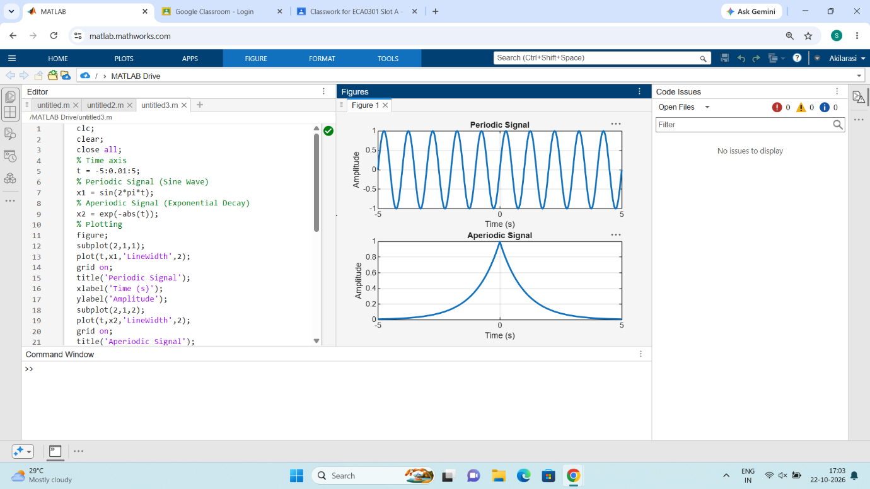

Result:
• Periodic Signal: The sinusoidal signal repeats itself at regular intervals, making it
periodic.
• Aperiodic Signal: The exponentially decaying signal does not repeat, showcasing
that it is aperiodic.
This test case illustrates the key differences between periodic and aperiodic signals by
generating and visually analysing both types using MATLAB.

